CIRCLE

Circle was a survey of international constructive art published in London in 1937. The joint editors and organisers of the parallel ‘Exhibition of Constructive Art’ were émigré Russian sculptor, Naum Gabo (1890 – 1977), British abstract artist, Ben Nicholson, and modernist British architect, Leslie Martin. Gabo was one of several European artists and architects who migrated to England in the late 1930s to escape Nazi and Soviet oppression. In London, Gabo became a friend of Ben Nicholson with whom he discussed starting an annual publication that would promote the constructivist concept that called for the synthesis of modernist architecture and constructivist painting and sculpture. Circle was the outcome of these discussions. The book and corresponding exhibition constituted the first comprehensive exposition of constructive art in Britain. Circle featured fifty-one participants, including ten from Britain. However, while those from overseas included major international figures such as Mondrian, Léger, Gropius and Le Corbusier, the British artists – with the exception of Nicholson, Barbara Hepworth and Henry Moore – were far less well-known and the constructivist credentials of several were weak. The editors’ intention to publish Circle annually was frustrated by the outbreak of Second World War and the departure of Gabo and others to the USA.

Naum Gabo was a leading Russian exponent of Constructivism who emigrated to England in 1936 after leaving Russia and then living for a time in Germany. In London, together with Mondrian, he became a neighbour and friend of Ben Nicholson and constructivist artist John Cecil Stephenson. From these contacts emerged a plan to launch an annual publication, Circle, as a survey of international constructive art. Circle incorporated painting, sculpture and architecture, and corresponding exhibitions were held to showcase the merging of modernist architecture and constructivist painting and sculpture that the publication presented. Gabo co-edited Circle alongside Nicholson and architect Leslie Martin. The book was published in 1937 alongside an exhibition of constructive art in the London Gallery.

The book’s editor claimed that “a new cultural unity is slowly emerging out of the fundamental changes which are taking place in our present-day civilization” and that this unity represented “the constructive trend in the art of our day.” To support these claims, the book showed 170 photographs of the work of twenty one painters, ten sculptors and twenty architectural practices. The exhibition was less comprehensive. Circle also included a number of illustrated essays by artists and architects in addition to work by art critics Herbert Read and Sigfried Geidion, modernist typographer, Jan Tschichold and the scientist J.D. Bernal. Read, who had previously commented that Nicholson’s white reliefs were “the best type of painting to go with the new architecture,” wrote about the search for new forms of artistic expression and suggested, “there is no one way of doing this … we are at a stage of experimentation.” A wide range of ideas within Circle’s “constructive” sub-title were also evident from differences in the authors’ essays. For example, Mondrian, unlike Gabo, made no reference to constructivism in expounding his philosophy of neo-plasticism, while Bernal was concerned with art’s search for social utility and Nicholson suggested that “painting and religious experience are the same thing.” That said, the notion that artwork is essentially rational and constructed from basic elements underlays almost everything illustrated and written about in Circle.

The artists and architects illustrated in Circle included many major figures from across Europe, such as Arp, Gropius, Klee, Corbusier, Léger, Moholy Nagy, and Mondrian. Whether some of the British artists, apart from John Cecil Stephenson (1889 – 1965), merited a constructivist label is also up for debate. Hepworth and Moore were making bio-morphic sculptures while painters Arthur Jackson, John Piper and Winifred Dacre were experimenting with hard-edge abstraction. Nicholson, too, slowly abandoned a constructivist approach when he later became the dominant landscape-influenced abstractionist of the St Ives artists. Nevertheless, Circle maintains its significance as the first event in British art history in which a comprehensive array of international constructive art, including a British component, was presented to the British art world.

References and further reading

Checkland S. J., (2000), Ben Nicholson: the Vicious Circle of his Life and Art,
London: John Murray.
Harrison C., (1981) English Art and Modernism 1900 – 1939, New Haven & London:
Yale University Press.
Martin J.L., Nicholson B., Gabo. N., eds. (1937) Circle, London: Faber & Faber
Nash A., Merket J., eds (1985) Naum Gabo: 60 Years of Constructivism, New York:
Prestel Verlag.
Read H., in Axis magazine April 1935, p. 16.

Images
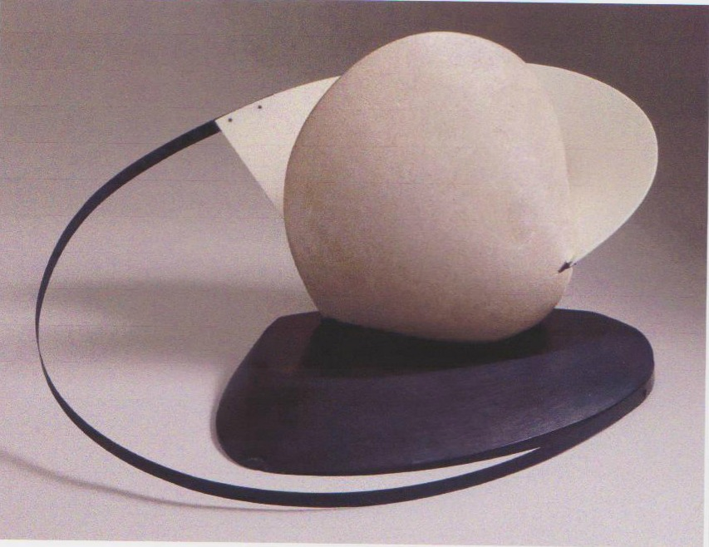
Naum Gabo, Stone with a Collar, 1936/7, limestone, brass, slate, 37 x 72 55 cms
www.tate.org.uk/art/artworks/gabo-construction-stone-with-a-collar/t06975

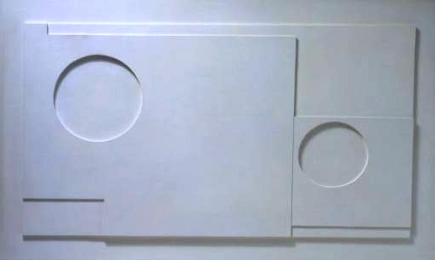
Ben Nicholson, White Relief, 1935, painted wood, 42.3 x 67.6 cms

www.mutualart.com/artwork/1935-white-relief/084F603C64BBD135

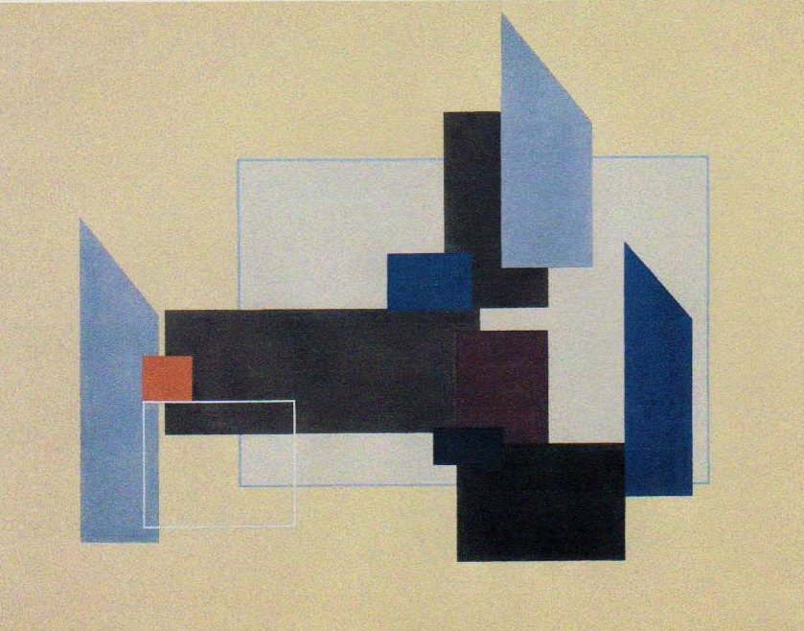
John Cecil Stephenson, Painting, 1937, tempera on canvas, 71.1 x 91.4 cms

www.tate.org.uk/art/artworks/stephenson-painting-t00617

